# Architectural Diagram

# Architectural Design for OOP:

## Representing the system in context

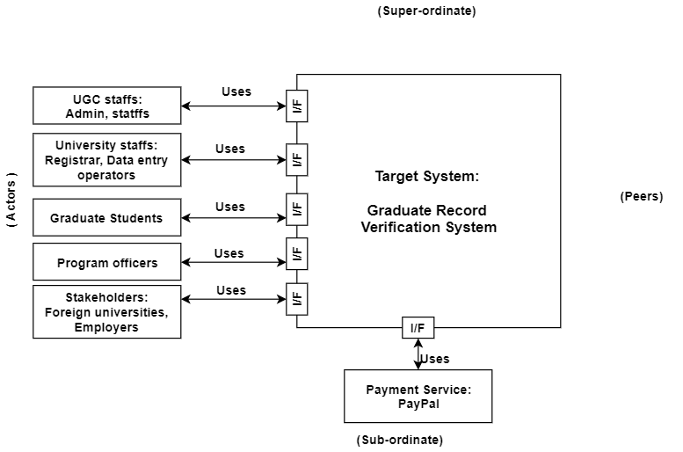

Figure 1.1.1: Representing the system in context

## Define Archetypes

1. User creation
2. Authentication
3. Viewing activity log
4. Report generation
5. Viewing and editing personal information
6. Viewing academic information
7. Viewing payment request from stakeholders
8. Paying through PayPal
9. Adding universities information and it’s registration’s details
10. Adding, removing, updating student information
11. Adding digital signature to verify students
12. Adding course and semester
13. Insertion of semester wise result
14. Validating candidate students information
15. Sending payment request
16. Sending notification to attach digital signature
17. Sending link to stakeholder

## Refining architecture into components

**Components:**

1. Admin details, registrar details, student details, program officer details, foreign university details, UGC staff details.
2. Admin details, registrar details, student details, program officer details, foreign university details, UGC staff details.
3. Activity log details
4. Report details
5. Admin details, registrar details, student details, program officer details, foreign university details, UGC staff details.
6. Student details
7. Foreign university details
8. Student details
9. University details, registrar details
10. Student details
11. Student details
12. Course details, semester details
13. Result details, semester details
14. Foreign university details
15. Student details, foreign university details
16. Registrar details
17. Foreign university details

**Classes:**

1. Admin, Registrar, Student, Program Officer, Foreign University, UGC staff, DAL
2. Admin, Registrar, Student, Program Officer, Foreign University, UGC staff, DAL
3. DAL
4. Report, DAL
5. Admin, Registrar, Student, Program Officer, Foreign University, UGC staff, DAL
6. Student
7. University
8. Student
9. Registrar, University
10. Student
11. Student
12. Course, Semester
13. Result, Semester
14. Foreign University, Student
15. Student, Foreign University
16. Registrar
17. Foreign University

## Describing Instantiation of the system

